**SALMAN AHMED KHAN**

**19K-1043**

**CN LAB 10**

**STATIC ROUTING**

**TOPOLOGY**

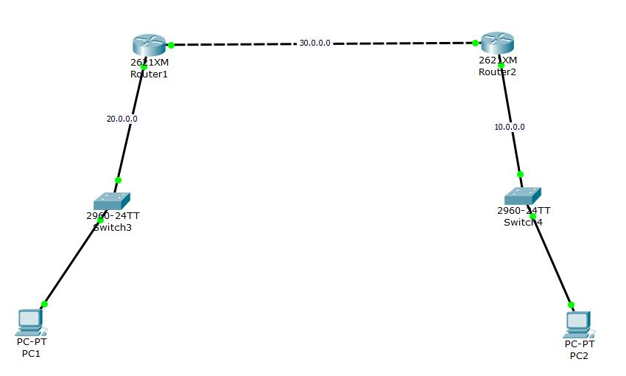

**ROUTER 1 CONFIG**

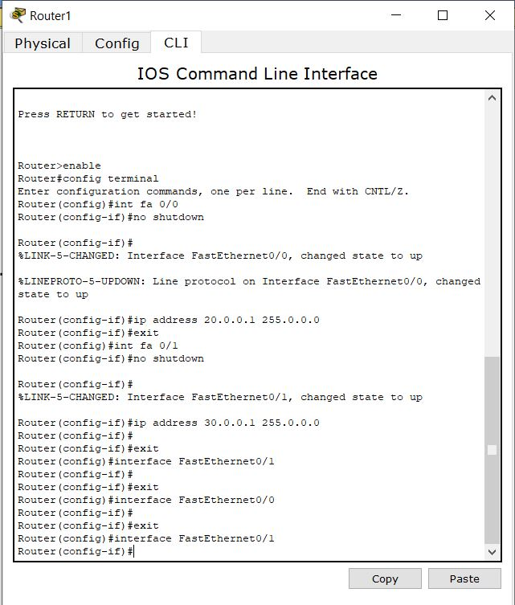

**PC 1 IP CONFIG**

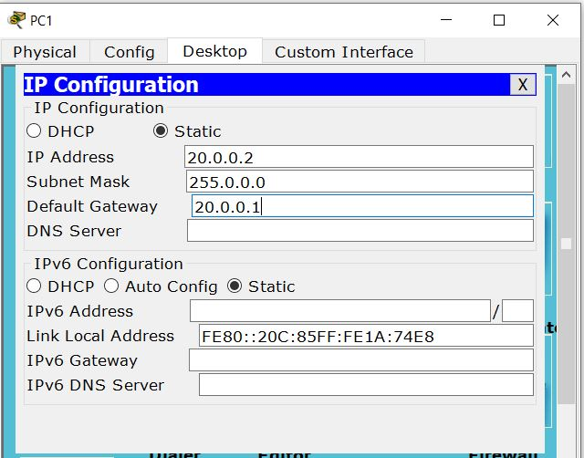

**ROUTER 2 CONFIG**

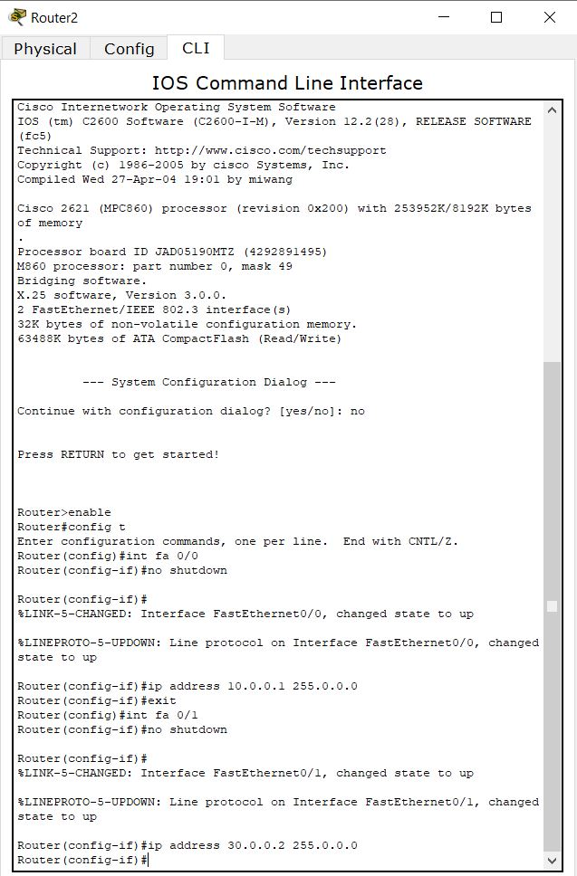

**PC 2 IP CONFIG**

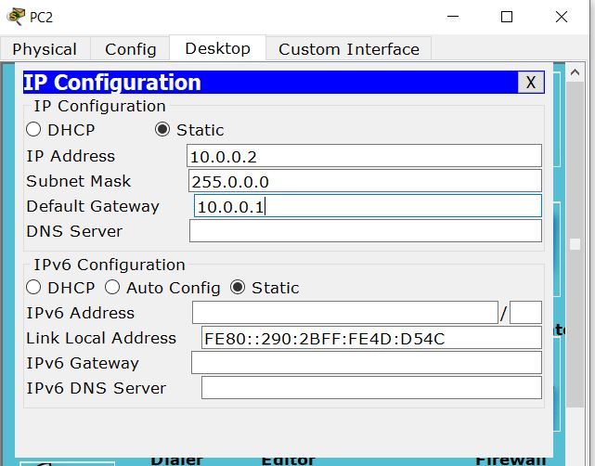

**ROUTER 1 STATIC ROUTING**

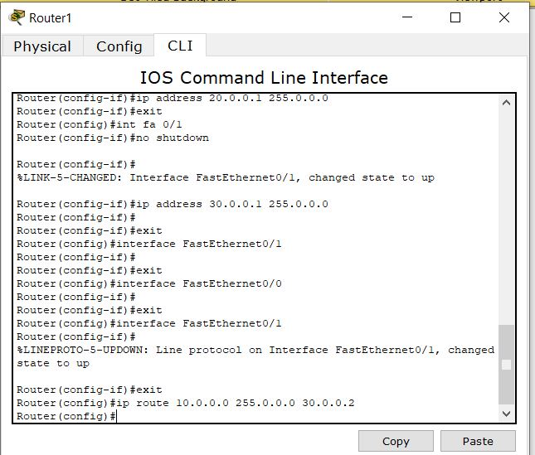

**ROUTER 2 STATIC ROUTING**

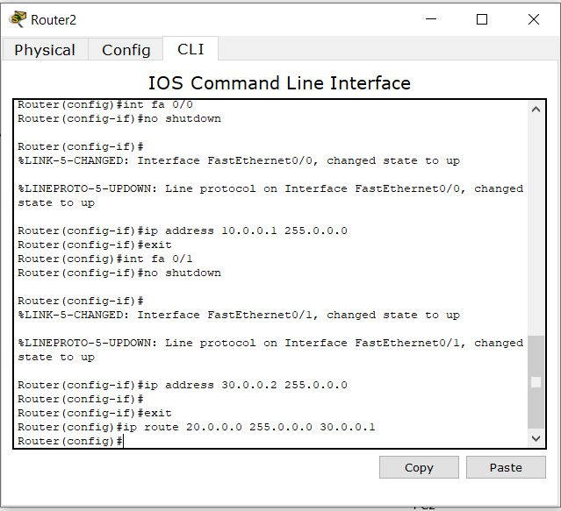

**PC 1 PING PC2**

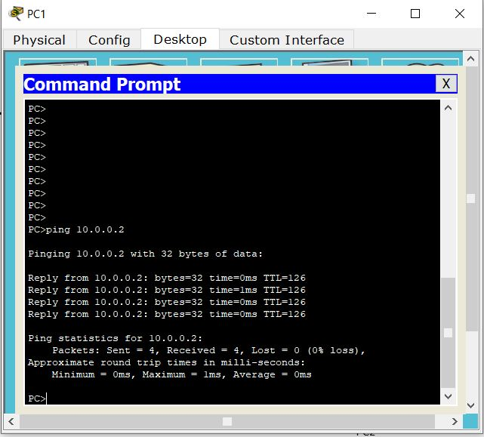

**PC 2 PING PC1**

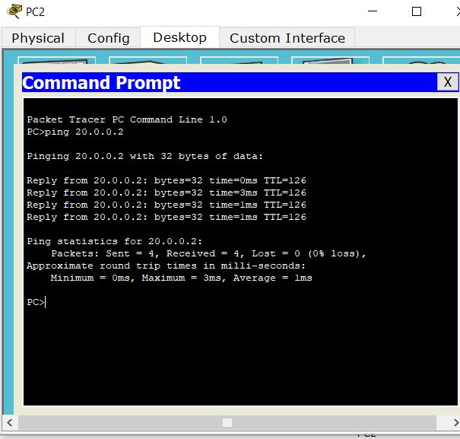

**ROUTER 1 ROUTING TABLE**

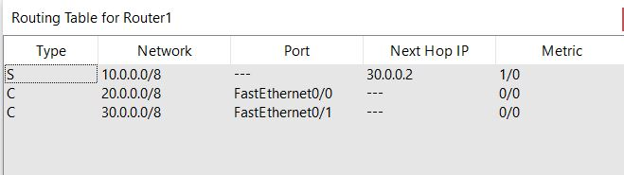

**ROUTER 2 ROUTING TABLE**

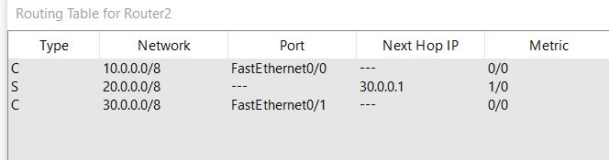

**DYNAMIC ROUTING: RIP**

**ROUTER 1 RIP CONFIG**

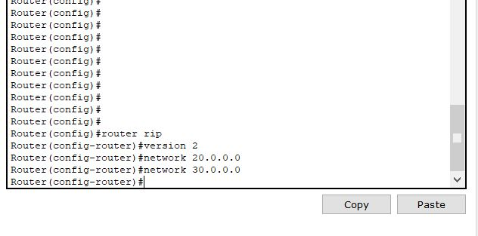

**ROUTER 2 RIP CONFIG**

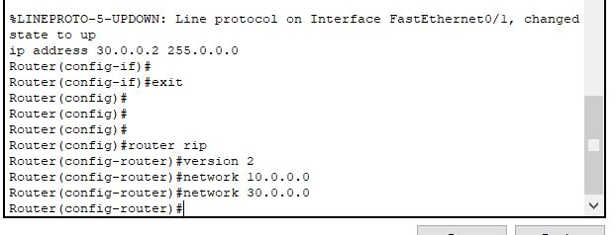

**ROUTER 1 ROUTING TABLE**

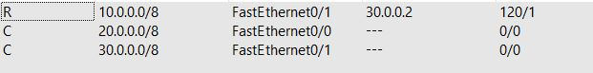

**ROUTER 2 ROUTING TABLE**

